Lab 3: Keyed Streams and Stateful Timers

**Goal:** Introduce stateful stream processing by partitioning a data stream, applying stateful logic with a ProcessFunction, and using Flink's timer service for time-based event detection.

# 

# 

# 

# 

# INDEX

**Purpose of this Lab** **3**

**Prerequisites** **3**

**Project Structure** **4**

Part 1: Project and Environment Setup 4

Part 2: Setting Up the Kafka Cluster 6

Part 3: Developing the Stateful Flink Application 7

Part 4: Executing the End-to-End Pipeline 12

Part 5: Verification 13

Part 6: Cleanup 15

Part 7: Next Steps 16

# 

# Purpose of this Lab

This lab transitions from the stateless ETL of Lab 2 to stateful stream processing, a core strength of Apache Flink. You will count "add-to-cart" events for each product and, more importantly, detect when a product becomes "idle" (hasn't received an event for a specified duration).

This is achieved by partitioning the data stream with keyBy and then implementing a ProcessFunction, which gives you fine-grained control over both state and time. By completing this lab, you will:

**Partition a DataStream:** Logically group an unbounded stream into distinct partitions using the keyBy transformation.

**Implement a ProcessFunction:** Define and apply a ProcessFunction for advanced, stateful stream manipulation.

**Manage State:** Declare, access, and update Flink's managed ValueState within a keyed context.

**Use Timers:** Register and react to processing-time timers to implement custom, time-based application logic.

**Understand Stateful Execution:** Observe how Flink isolates state per key and manages the lifecycle of state and timers.

# Prerequisites

This lab assumes you have successfully completed Lab 1 and Lab 2 and are using an **Ubuntu** environment. Your Flink cluster should already have the Kafka connector JAR in its lib directory from the previous lab.

# Project Structure

By the end of this lab, your new project directory will be structured as follows:

| ~/flink-lab-3/ ├── venv/ # The isolated Python virtual environment ├── docker-compose.yaml # Defines our Kafka service ├── producer.py # The script to generate mock data └── stateful_timers.py # The Flink stateful job script |
| --- |

### **Part 1: Project and Environment Setup**

**Step 1: Create Project Directory and Virtual Environment** We'll create a new, separate directory for this lab.

Create and navigate to the new lab directory

| mkdir ~/flink-lab-3 cd ~/flink-lab-3 |
| --- |

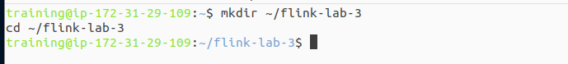

Initialize and activate a Python virtual environment

| python -m venv venv source venv/bin/activate |
| --- |

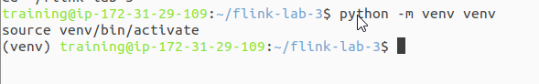

**Step 2: Install Python Dependencies** With the venv active, install apache-flink and the Python client for Kafka.

| pip install "apache-flink==2.0.0" kafka-python |
| --- |

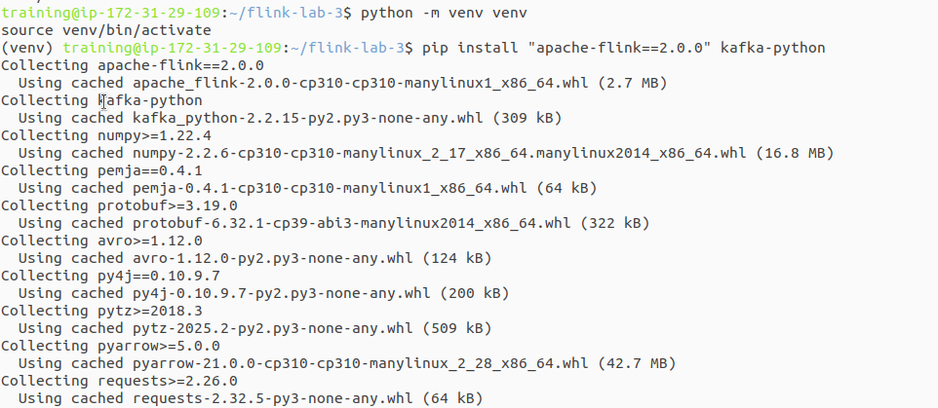

**Step 3: Configure Flink for the New Project** Since we created a new virtual environment, we must update Flink's configuration to point to the correct Python executable for this lab.

Get the absolute path to the Python executable in the new venv

| VENV_PYTHON_PATH=$(which python) |
| --- |

This command finds and replaces the 'python.executable' line, or adds it if not present.

| if grep -q "^python.executable:" "$FLINK_HOME/conf/flink-conf.yaml"; then  sed -i.bak "s#^python.executable:.*#python.executable: $VENV_PYTHON_PATH#" "$FLINK_HOME/conf/flink-conf.yaml"  echo "Updated python.executable path in flink-conf.yaml" else  echo "python.executable: $VENV_PYTHON_PATH" >> "$FLINK_HOME/conf/flink-conf.yaml"  echo "Added python.executable path to flink-conf.yaml" fi |
| --- |

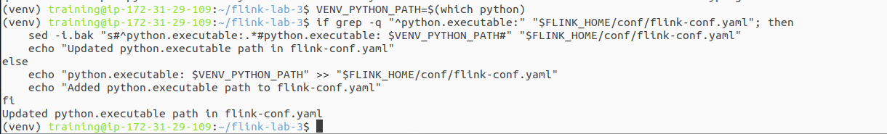

### **Part 2: Setting Up the Kafka Cluster**

**Step 1: Define the Kafka Service** Create a file named docker-compose.yaml in the ~/flink-lab-3 directory. This is identical to the file from Lab 2.

| code docker-compose.yaml |
| --- |

Add the following content to the file:

| # docker-compose.yaml services:  zookeeper:  image: confluentinc/cp-zookeeper:7.3.2  container_name: zookeeper  ports: ["2181:2181"]  environment:  ZOOKEEPER_CLIENT_PORT: 2181  ZOOKEEPER_TICK_TIME: 2000  kafka:  image: confluentinc/cp-kafka:7.3.2  container_name: kafka  ports: ["9092:9092"]  depends_on: [zookeeper]  environment:  KAFKA_BROKER_ID: 1  KAFKA_ZOOKEEPER_CONNECT: zookeeper:2181  KAFKA_ADVERTISED_LISTENERS: PLAINTEXT://kafka:29092,PLAINTEXT_HOST://localhost:9092  KAFKA_LISTENER_SECURITY_PROTOCOL_MAP: PLAINTEXT:PLAINTEXT,PLAINTEXT_HOST:PLAINTEXT  KAFKA_INTER_BROKER_LISTENER_NAME: PLAINTEXT  KAFKA_OFFSETS_TOPIC_REPLICATION_FACTOR: 1 |
| --- |

**Step 2: Launch the Kafka Cluster** From the ~/flink-lab-3 directory, start the services.

| docker compose up -d |
| --- |

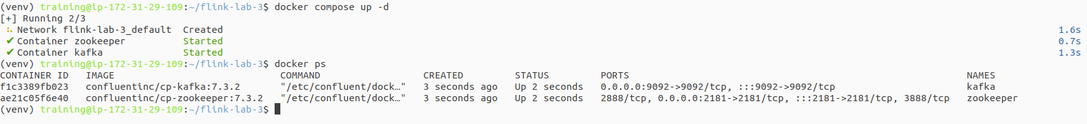

### **Part 3: Developing the Stateful Flink Application**

**Step 1: Implement the Kafka Producer** Create a file named producer.py. We will use the same robust producer with retry logic from Lab 2.

| code producer.py |
| --- |

Add the following code:

| # producer.py import json import time import random from kafka import KafkaProducer from kafka.errors import NoBrokersAvailable  KAFKA_TOPIC = 'clicks' KAFKA_BROKERS = 'localhost:9092'  def create_producer():  """Creates a KafkaProducer with retry logic."""  retries = 10  while retries > 0:  try:  producer = KafkaProducer(  bootstrap_servers=KAFKA_BROKERS,  value_serializer=lambda v: json.dumps(v).encode('utf-8')  )  print("Successfully connected to Kafka.")  return producer  except NoBrokersAvailable:  retries -= 1  print(f"Kafka not available, retrying in 5 seconds... ({retries} retries left)")  time.sleep(5)  raise RuntimeError("Failed to connect to Kafka after multiple retries.")  if __name__ == '__main__':  producer = create_producer()    print("Producing mock click events... Press Ctrl+C to terminate.")  user_ids = [f'user_{i}' for i in range(1, 11)]  product_ids = [f'prod_{i}' for i in range(1, 6)]  event_types = ['page_view', 'page_view', 'page_view', 'add_to_cart']  try:  while True:  event = {  'event_type': random.choice(event_types),  'user_id': random.choice(user_ids),  'product_id': random.choice(product_ids),  'timestamp': int(time.time() * 1000)  }  producer.send(KAFKA_TOPIC, value=event)  print(f"Sent event: {event}")  time.sleep(1)  except KeyboardInterrupt:  print("\nStopping producer.")  finally:  producer.flush()  producer.close() |
| --- |

**Step 2: Implement the Stateful Flink Script** Create the main Flink application file, stateful_timers.py.

| code stateful_timers.py |
| --- |

Add the following code:

| # stateful_timers.py from pyflink.common import Types from pyflink.datastream import StreamExecutionEnvironment from pyflink.datastream.connectors.kafka import KafkaSource, KafkaOffsetsInitializer from pyflink.datastream.formats.json import JsonRowDeserializationSchema from pyflink.common.watermark_strategy import WatermarkStrategy from pyflink.datastream.functions import KeyedProcessFunction, RuntimeContext from pyflink.datastream.state import ValueStateDescriptor  class IdleProductDetector(KeyedProcessFunction):  """  A KeyedProcessFunction that maintains a count for each product_id and  detects when a product has been "idle" (no events for 1 minute).  """   def __init__(self):  self.count_state = None  self.timer_state = None   def open(self, runtime_context: RuntimeContext):  # Initialize state descriptors. This is called once per parallel instance.  count_descriptor = ValueStateDescriptor("event_count", Types.INT())  self.count_state = runtime_context.get_state(count_descriptor)   timer_descriptor = ValueStateDescriptor("idle_timer", Types.LONG())  self.timer_state = runtime_context.get_state(timer_descriptor)   def process_element(self, value, ctx: 'KeyedProcessFunction.Context'):  # 1. Retrieve and update count state  current_count = self.count_state.value()  if current_count is None:  current_count = 0  new_count = current_count + 1  self.count_state.update(new_count)   # 2. Manage timers to detect idle products  # Delete the previous timer if it exists  previous_timer_ts = self.timer_state.value()  if previous_timer_ts is not None:  ctx.timer_service().delete_processing_time_timer(previous_timer_ts)   # Register a new timer for 1 minute in the future  new_timer_ts = ctx.timer_service().current_processing_time() + 60 * 1000  ctx.timer_service().register_processing_time_timer(new_timer_ts)  self.timer_state.update(new_timer_ts)   # Emit the current product and its updated count  yield f"Product: {ctx.get_current_key()}, Count: {new_count}"   def on_timer(self, timestamp: int, ctx: 'KeyedProcessFunction.OnTimerContext'):  # This method is invoked when a processing-time timer fires.  # Check if the timer that fired is the one we have stored.  stored_timer_ts = self.timer_state.value()  if stored_timer_ts is not None and stored_timer_ts == timestamp:  product_key = ctx.get_current_key()  event_count = self.count_state.value()  yield f"[IDLE ALERT] Product '{product_key}' has been idle for 1 minute. Last count was {event_count}."    # Clean up state for this key as it's now considered idle  self.count_state.clear()  self.timer_state.clear()  def main():  env = StreamExecutionEnvironment.get_execution_environment()   type_info = Types.ROW_NAMED(  ["event_type", "user_id", "product_id", "timestamp"],  [Types.STRING(), Types.STRING(), Types.STRING(), Types.LONG()]  )   json_deserializer = JsonRowDeserializationSchema.builder() \  .type_info(type_info).build()   kafka_source = KafkaSource.builder() \  .set_bootstrap_servers('localhost:9092') \  .set_topics('clicks') \  .set_group_id('flink-stateful-group') \  .set_starting_offsets(KafkaOffsetsInitializer.latest()) \  .set_value_only_deserializer(json_deserializer) \  .build()   data_stream = env.from_source(  source=kafka_source,  watermark_strategy=WatermarkStrategy.no_watermarks(),  source_name="kafka_source"  )   # Filter for 'add_to_cart' events, key by product_id, and apply the process function  keyed_stream = data_stream \  .filter(lambda event: event.event_type == 'add_to_cart') \  .key_by(lambda event: event.product_id)   # Apply the custom KeyedProcessFunction  output_stream = keyed_stream.process(IdleProductDetector(), output_type=Types.STRING())   output_stream.print()  env.execute("stateful_timers_and_keyed_streams")  if __name__ == '__main__':  main() |
| --- |

### **Part 4: Executing the End-to-End Pipeline**

You will need three separate terminal windows.

**Terminal 1: Start the Flink Cluster** If your Flink cluster is not already running, restart it to ensure it's using the latest configuration.

If running, stop it first

| stop-cluster.sh |
| --- |

Start the cluster

| start-cluster.sh |
| --- |

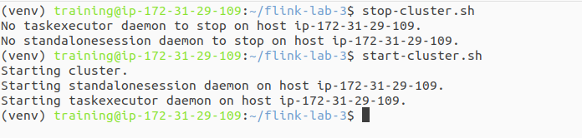

**Terminal 2: Launch the Data Producer** Navigate to your lab directory, activate the environment, and start the producer script.

| cd ~/flink-lab-3 source venv/bin/activate python producer.py |
| --- |

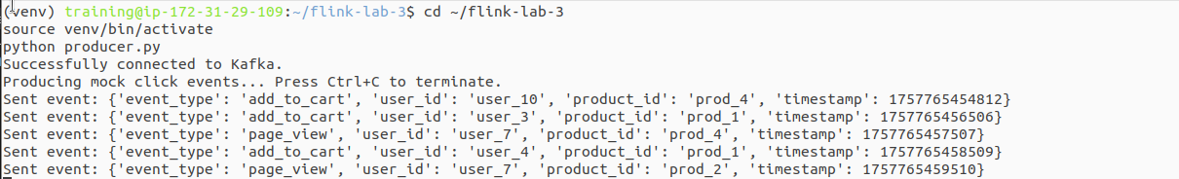

**Terminal 3: Submit the Flink Application** Because we placed the Kafka connector in Flink's lib directory, we can submit the job with a simple command.

| cd ~/flink-lab-3 source venv/bin/activate flink run -py stateful_timers.py |
| --- |

### 

### **Part 5: Verification**

**Step 1: Verify Job Execution** Go to the Flink UI at http://localhost:8081. The stateful_timers_and_keyed_streams job should appear in the "Running Jobs" section.

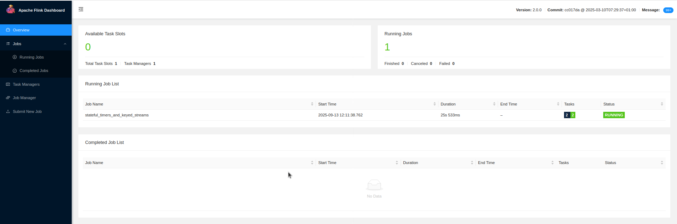

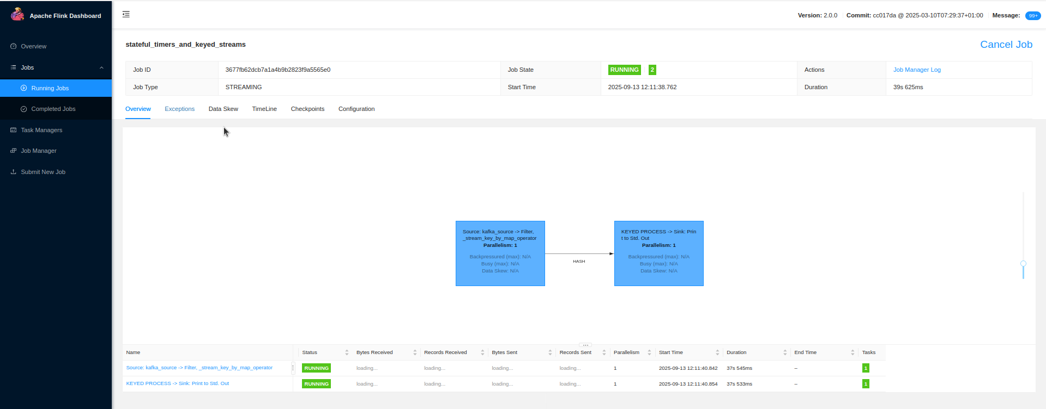

**Step 2: Inspect the Output** View the TaskManager logs to see the running counts for each product.

| tail -f $(ls -t $FLINK_HOME/log/flink-*-taskexecutor-*.out | head -n 1) |
| --- |

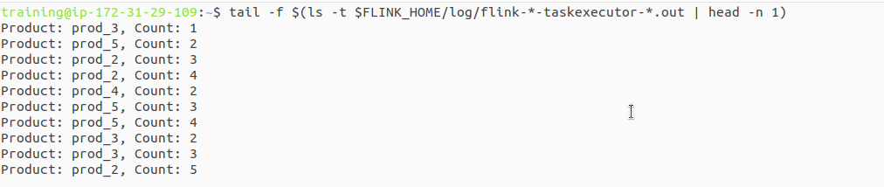

**Step 3: Wait for Idle Alerts** The producer script sends events for 5 different products. Wait for a minute or two. Due to the random nature of the producer, it is highly likely that at least one product will not receive an "add-to-cart" event for over 60 seconds. When this happens, you will see an idle alert in the logs: [IDLE ALERT] Product 'prod_4' has been idle for 1 minute. Last count was 3.

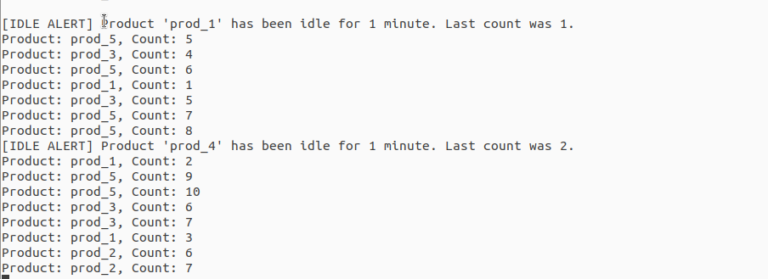

### **Part 6: Cleanup**

Once you have verified the pipeline is working, shut down all the components to free up system resources.

**Stop the Flink job:** Press Ctrl+C in Terminal 3.

**Stop the producer:** Press Ctrl+C in Terminal 2.

**Stop the Flink cluster:** stop-cluster.sh

**Stop the Kafka cluster:** cd ~/flink-lab-3 && docker compose down

**Deactivate the python environment:** deactivate in Terminals.

### **Part 7: Next Steps**

**Different State Types:** Explore other state types like ListState to store a history of events for each key.

**Event-Time Timers:** Modify the job to use event-time processing and timers, which are crucial for handling out-of-order data.

**Fault Tolerance:** Learn about Flink's checkpointing mechanism to see how it guarantees state consistency in case of failures.